Connect to Oracle DB via JDBC driver

By [mkyong](https://www.mkyong.com/author/mkyong/" \o "mkyong class=) | January 18, 2011 | Updated : June 20, 2019 | Viewed : 838,304 | +1,294 pv/w

A JDBC example to show you how to connect to a Oracle database with a JDBC driver.

*Tested with:*

* Java 8
* Oracle database 19c
* Oracle JDBC driver for Java 8, ojdbc8.jar

1. Download Oracle JDBC Driver

Visit [Oracle database website](https://www.oracle.com/technetwork/database/application-development/jdbc/downloads/index.html) and download the Oracle JDBC Driver.

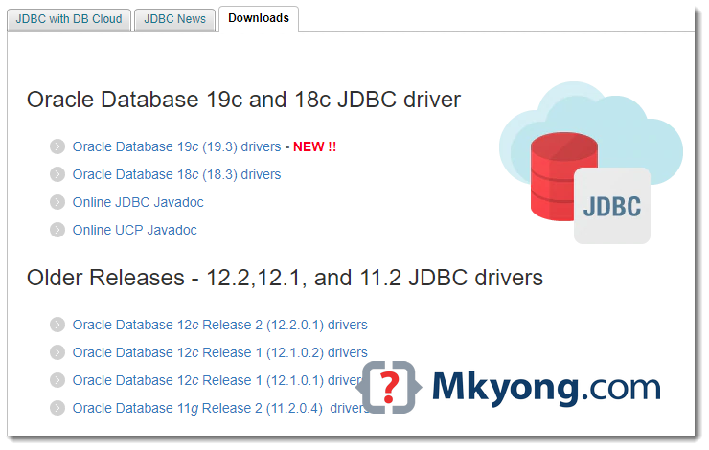

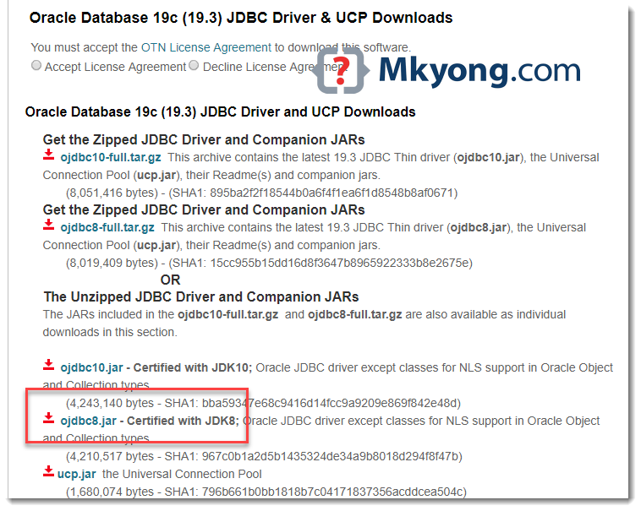

2. JDBC Connection

**Note**  
Find your Oracle SID in {ORACLE_HOME}/network/admin/tnsnames.ora to avoid the popular [ORA-12505, TNS:listener does not currently know of SID](https://www.mkyong.com/jdbc/ora-12505-tnslistener-does-not-currently-know-of-sid-given-in-connect-descriptor/)

2.1 Make a connection to the Oracle database.

JDBCExample.java

import java.sql.Connection;

import java.sql.DriverManager;

import java.sql.SQLException;

public class JDBCExample {

public static void main(String[] args) {

// https://docs.oracle.com/javase/8/docs/api/java/sql/package-summary.html#package.description

// auto java.sql.Driver discovery -- no longer need to load a java.sql.Driver class via Class.forName

// register JDBC driver, optional since java 1.6

/*try {

Class.forName("oracle.jdbc.driver.OracleDriver");

} catch (ClassNotFoundException e) {

e.printStackTrace();

}*/

// Oracle SID = orcl , find yours in tnsname.ora

try (Connection conn = DriverManager.getConnection(

"jdbc:oracle:thin:@localhost:1521:orcl", "system", "Password123")) {

if (conn != null) {

System.out.println("Connected to the database!");

} else {

System.out.println("Failed to make connection!");

}

} catch (SQLException e) {

System.err.format("SQL State: %s\n%s", e.getSQLState(), e.getMessage());

} catch (Exception e) {

e.printStackTrace();

}

}

}

Copy

Compile and run:

C:\test> javac JDBCExample.java

C:\test> java JDBCExample

SQL State: 08001

No suitable driver found for jdbc:oracle:thin:@localhost:1521:orcl

Copy

2.2 Assume ojdbc8.jar and JDBCExample.java are stored in c:\test together. Define a -cp option to load everything together:

> java -cp "c:\test\ojdbc8.jar;c:\test" JDBCExample

Connected to the database!

Copy

3. Maven Project 🡪 여기는 나중에 확인할 것

3.1 Sorry, due to Oracle license restriction, the Oracle JDBC driver is NOT available in the Maven central repository. Follow this guide to add it – [How to add Oracle JDBC driver in your Maven local repository](https://www.mkyong.com/maven/how-to-add-oracle-jdbc-driver-in-your-maven-local-repository/)

3.2 Alternatively, defined a system scope to find the .jar file with a specified system path.

pom.xml

<dependency>

<groupId>com.oracle</groupId>

<artifactId>ojdbc</artifactId>

<version>8</version>

<scope>system</scope>

<systemPath>d:/projects/ojdbc8.jar</systemPath>

</dependency>

Copy